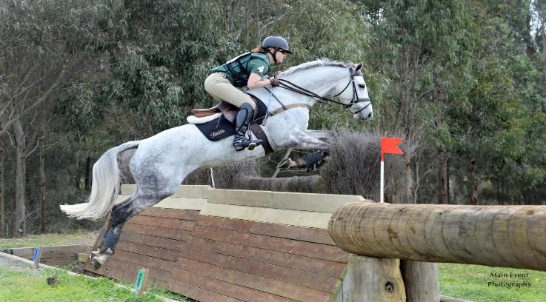 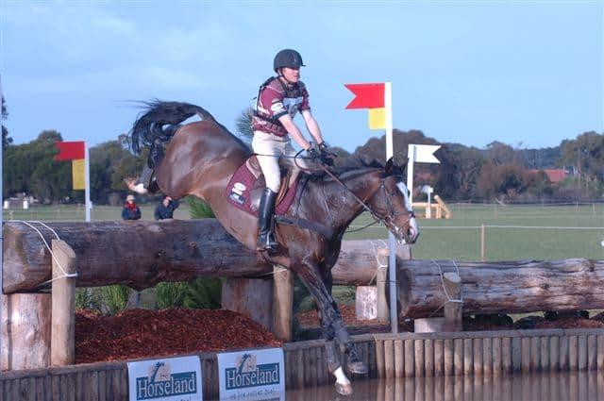
The Coaching NSW Committee is proud to present a
PERSONAL DEVELOPMENT CLINIC
for currently accredited NSW EA Coaches
Monday, 8 June, 2020 at Sandhills, Branxton, NSW

PRUE BARRETT AND CRAIG BARRETT COACHING MASTERCLASS
Prue will be coaching lower level horse and rider combinations, including an off the track thoroughbred, an 80cm Junior and a 95cm combination. Craig will be coaching * horses. This is a fantastic opportunity to observe a variety of horse and rider combinations.
The Masterclass will commence at 9.30am sharp and will conclude approximately 1.30pm after the refreshment break and Q&A session.
Cost to attend is $55. Due to COVID-19 requirements, attendants will be required to provide their own chair, refreshments and lunch.
RSVP by 5pm, Tuesday, 2 June, 2020 by completing the registration form on the following page. Registrations will be accepted in order of receipt on a first come, first served basis.
Attendance numbers at this clinic are strictly limited and will need to comply with relevant COVID-19 health orders applicable on the date of the Masterclass. A Sydney based clinic is also planned for the upcoming months.

Craig Barrett EA Level 2 Eventing and Dressage Coach Educator - Prue Barrett EA Level 2 Eventing Coach Educator
Together, they have over 50 years of experience in competing and coaching at the highest level in Eventing. Both Australian Eventing representatives Prue was National Eventing Coach for 6 years including London Olympics, 2014 WEG, 2016 Rio where the team won Bronze. Craig has coached numerous riders including Christine Bates, Jess Grosmann, just to name a couple through to 4 and 5* success. Both Craig and Prue are committed to the coaching of riders in Eventing at all levels. Safety is of the highest priority along with enjoyment of the sport. These two elements are the cornerstone of longevity in the sport. They have mentored many coaches over the years and are more than happy to help other coaches become competent xc coaches.

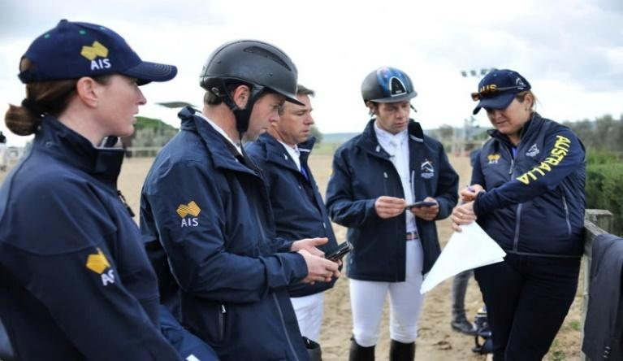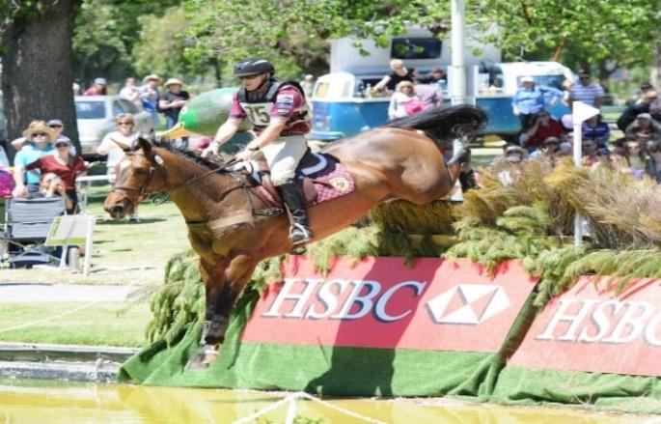
Equestrian NSW (ABN 17 157 619 696) and Equestrian NSW (ABN 19 077 455 755)
PO Box 7077, Wetherill Park BC NSW 2164
Ph: 02 9620 2660 Fax: 02 9620 2260 Website: www.nsw.equestrian.org.au
This form becomes a Tax Invoice on payment. Please copy for your records
PAYMENT INFORMATION

Email form to sue@ensw.org.au

REGISTRATION FORM
COACH PERSONAL DEVELOPMENT CLINIC
Prue Barrett and Craig Barrett Masterclass
Monday, 8 June, 2020 at Sandhills, Branxton, NSW.
Cost to attend: $55

Attendance numbers at this clinic are strictly limited and will need to comply with relevant COVID-19 health orders applicable on the date of the Masterclass.

Name: ________________________________________________________________________________

ENSW Membership Number: ______________________________________________________________

Coaching Accreditation: __________________________________________________________________

Please charge my credit card for $55:

- Visa
- Mastercard

Number: __ __ __ __/ __ __ __ __/ __ __ __ __/ __ __ __ __ Expiry date: __ __/ __ __ CCV: __ __ __ __

Name on Card: ____________________________________

Signature/Authorisation: ____________________________________

Office use only.
Date received: _____________
Time received: _____________

