

RISK MANAGEMENT PLAN
An ENSW Affiliated Club

Club Details
Club Name: | (Henceforth known as ‘The/ Our Club’)

Date Completed:
Next Review Date: | 12 months after completion

Disciplines Offered:

Members (No.):

Event location:

As an Equestrian NSW affiliated club, we comply with the Equestrian NSW Risk Management Policy which states that all risks shall be managed to be as low as reasonably practical. Specifically the Club Committee will:
- Collect relevant incident data and analyses, identify potential perils, factors and types of risks to which our club, its assets, activities and interests are exposed and detail these in a risk register showing a potential risk rating and what measures are in place, or planned, to address each identified risk.
- Allocate sufficient human and financial resources to ensure compliance with its risk management obligations.
- Clear assignment, understanding and acceptance of accountabilities for key personnel involved in risk management.
- Maintain insurance through renewal of Equestrian NSW affiliation annually.
- Where a harmful or damaging incident occurs, report the incident in accordance with the Equestrian Australia incident reporting requirements and investigate the incident to determine its root causes and identify opportunities for improvement to prevent a re-occurrence.

RISK CATEGORIES

The broad categories of risk to our club can be summarised as:

Risk Category | Description
Club Governance | The systems and structures by which a club is directed and controlled
Financial Management | Processes and practices for effective management of club funds.
Event Management | Risk assessment and risk management of events
People | Planning for and caring for the people within our club including members, officials, volunteers, and children
Horse Welfare | Ensuring the safety and welfare of our equestrian partners

PLAN CONTEXT

This plan was developed with reference to:
- ISO 31000:2018 – Risk Management Principles and Guidelines
- HB246:2010 – Guidelines for Managing Risk in Sport and Recreationl Organisations
- The Sport Australia Risk Management Process

Both standards contain the following process.

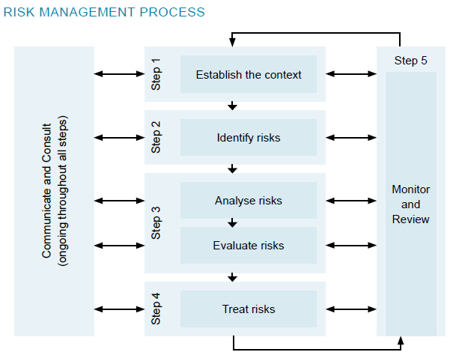

RISK EVENT HISTORY
In the last 10 years the following adverse events have occurred within our club:

Risk Category | Risk Event History
Club Governance
Financial Management
Event Management
People
Horse Welfare

RISK MATRIX

The following likelihood/impact and scale/definitions were adopted from the model recommended by Sport Australia.

Table 1– Likelihood Scale

Rating | LIKELIHOOD: The potential for problems to occur
5 | ALMOST CERTAIN: will probably occur, could occur several times per year
4 | LIKELY: high probability, likely to arise once per year
3 | POSSIBLE: reasonable likelihood that it may arise over a five-year period
2 | UNLIKELY: plausible, could occur over a five to ten year period
1 | RARE: very unlikely but not impossible, unlikely over a ten year period

Table 2 – Risk Matrix
 | Likelihood
Impact | Rare (1) | Unlikely (2) | Possible (3) | Likely (4) | Almost Certain (5)
Negligible (1) | L | L | L | M | M
Minor (2) | L | L | M | M | M
Moderate (3) | L | M | M | H | H
Major (4) | M | M | H | H | E
Catastrophic (5) | M | M | H | E | E

Table 3- Risk Management Requirements
Ranking | Code | Comment
Low |  | Observation
Medium |  | Must have measures in place
High |  | Must have an assurance program to ensure measures are in place and effective.
Extreme |  | Shall not be tolerated

This Risk Management Plan does not detail Low Risks, so that efforts are prioritised to managing Medium, High and Extreme risks.

CLUB RISK MANAGEMENT PLAN
RISK CATEGORY – HORSE AND RIDER WELFARE
Context – Our Club stage several competitions annually on our home ground, so has a duty of care to protect all stakeholders.
IMPACT/CONSEQUENCE
 | Rider & Spectator | Horse
5 | Death of rider or spectator | Increasing Multiple deaths
4 | Permanent serious injury | Individual deaths
3 | Serious injury requiring hospitalisation | Career ending injuries
2 | Medical treatment injury on site | Serious injury requiring hospitalisation
1 | Minor injury requiring first aid | Veterinary treatment on site

Risk Event | How it can occur | Mitigation & Risk Controls | Responsibility | Likelihood | Impact | Risk Ranking

CLUB RISK MANAGEMENT PLAN
RISK CATEGORY – PEOPLE
Context –Australian sporting organisations have legal obligations under Australian law with regard to harassment, discrimination and child protection. We also have moral obligations in relation to establishing standards of appropriate member behaviour and to provide a safe, respectful and appropriate sporting environment for equestrian activities to occur.
IMPACT/CONSEQUENCE
5 | Club becomes unviable and winds up
4 | Significant decrease in member numbers
3 | Members leave
2 | Members don’t renew
1 | Member dis-satisfaction

Risk Event | How it can occur | Mitigation & Risk Controls | Responsibility | Likelihood | Impact | Risk Ranking

CLUB RISK MANAGEMENT PLAN
RISK CATEGORY – BIOSECURITY
Context – Management of Biosecurity Risks is important to ensure that the transfer of diseases (eg Equine Influenza, Equine Herpes, Hendra, Strangles) from horse to horse and horse-to-human is managed appropriately. All people who bring horses to competitions and clinics are expected to be aware of their biosecurity obligations, that they must take all reasonable steps to ensure their activities do not spread a pest, disease or contaminant.
IMPACT/CONSEQUENCE
5 | Major pandemic
4 | Events cancelled
3 | Widespread incidents
2 | Multiple incidents
1 | Isolated minor incident

Risk Event | How it can occur | Mitigation & Risk Controls | Responsibility | Likelihood | Impact | Risk Ranking

EQUESTRIAN NSW RISK MANAGEMENT PLAN – FY21
RISK CATEGORY – FINANCE, COMMERCIAL & GOVERNANCE
Context – The Club is accountable to members and the relevant government agencies to comply with legislation and to continuously improve its finance, commercial and governance processes.
IMPACT/CONSEQUENCE
 | Finance | Commercial | Governance
5 | Illegal activity leading to prosecution | Unable to attract sponsorship | Breakdown causing dis-association
4 | Insolvency | Material reputational damage | Serial breaches
3 | Member funds exhausted | Loss of partners | Processes not followed
2 | Financial objectives not met | Breaching partner agreements | Processes not defined
1 | Minor loss of control | Not meeting partner needs | Processes not clear

Risk Event | How it can occur | Mitigation & Risk Controls | Responsibility | Likelihood | Impact | Risk Ranking

