Our Board
Meet the people providing strategic leadership and governance for Equestrian NSW.
The Equestrian NSW Board sets the strategic direction of the organisation and oversees governance, financial sustainability, risk and accountability. Board members bring a mix of equestrian knowledge and professional expertise to support a safe, inclusive and sustainable future for equestrian sport in New South Wales.

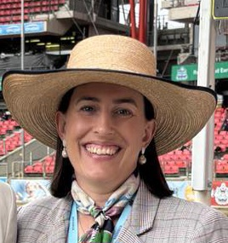 | Amy Eggleton  CHAIR – ELECTED DIRECTOR  Amy brings 20 years of experience across the finance and education sectors, with strengths in leadership, strategic management, risk, compliance and governance. She has held governance roles across equestrian sport, including Chair of the Equestrian NSW Finance, Audit and Risk Management Committee and Treasurer of Equestrian Queensland, as well as serving on the board of the Mudgee Chamber of Commerce.  Amy’s involvement in equestrian sport began in Pony Club and has continued as a competitor, horse owner, breeder, volunteer and administrator. She has competed across eventing, dressage and showjumping and remains actively involved in grassroots and regional equestrian communities.  As Chair, Amy is focused on strong governance, long-term sustainability and ensuring NSW members are well represented in the broader direction of Australian equestrian sport. She is passionate about regional participation, supporting volunteers and officials, horse welfare and protecting the sport’s social licence.  Amy holds a Master of Business (Human Resource Management), a Bachelor of Equine Business Management and has completed Governance Foundations for Not-for-Profit Directors through the Australian Institute of Company Directors.  Areas of expertise: Governance | Leadership & strategy | Finance & risk | Stakeholder management | Equestrian sport

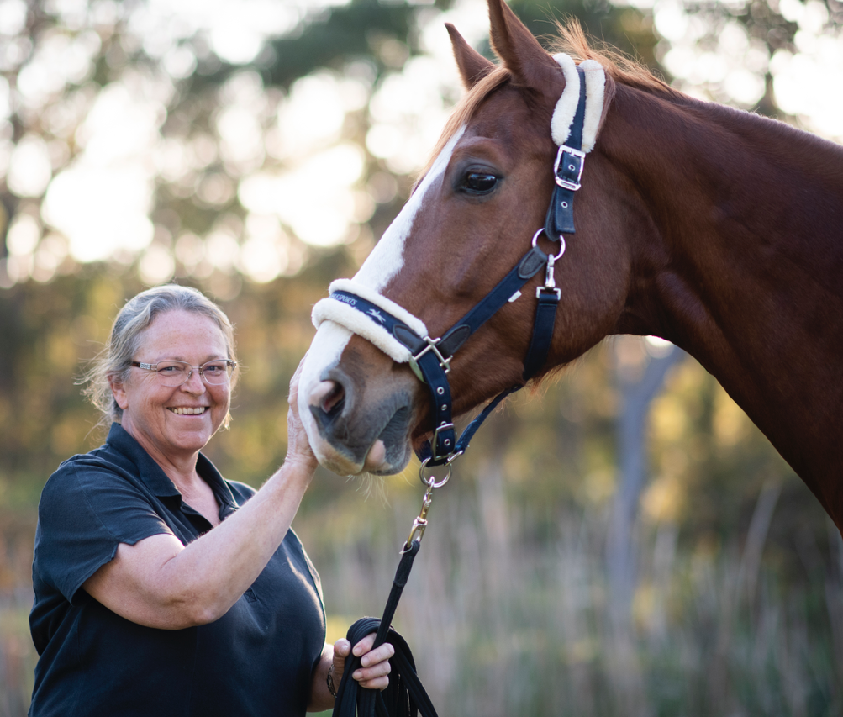 | Dr Gillian Burns  ELECTED DIRECTOR  Dr Gillian Burns combines veterinary and equine rehabilitation expertise with extensive equestrian governance and volunteer leadership. A lifelong rider, she has also been actively involved in equestrian vaulting and has competed as a lunger. Gillian has served on the Equestrian NSW Board, the Equestrian Australia Vaulting Committee and chaired Vaulting NSW for seven years. A veterinarian with experience in mixed and equine practice, she undertook further study in equine back pain and rehabilitation and established a practice focused on equine rehabilitation. Her FEI roles have included Permitted Treating Veterinarian, Veterinary Vaulting Delegate and Testing Veterinarian, and in 2015 she was team veterinarian for the Australian Vaulting Team at the Junior World Vaulting Championships. Gillian holds BS and DVM degrees from Oklahoma State University and a Diploma in Equine Manipulation, bringing a strong horse-welfare and evidence-based perspective to the Board.  Areas of expertise: Horse welfare | Veterinary expertise | Vaulting | Event governance & integrity

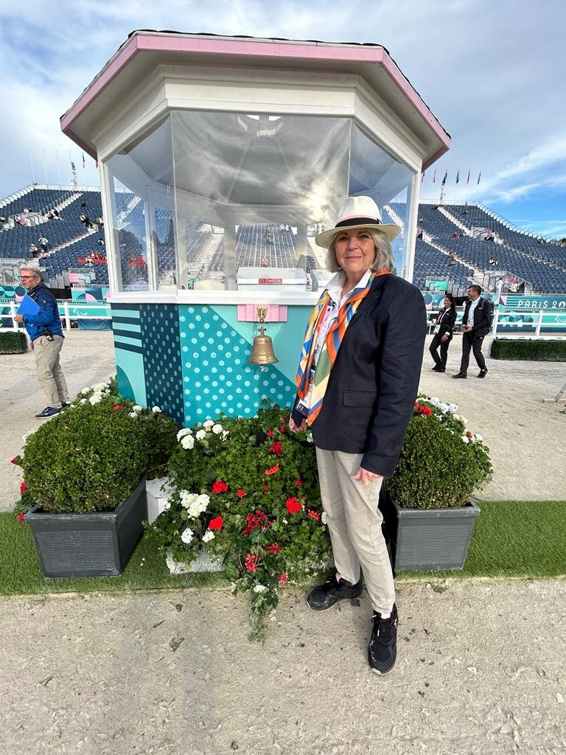 | Suzanne Cunningham  ELECTED DIRECTOR  Suzanne Cunningham brings more than two decades of leadership, governance and strategic oversight across equestrian sport at state, national and international levels. She has served on the Equestrian NSW Board since 2021 and previously spent nine years on the Dressage NSW Committee, where she led judge education and supported the development of education pathways and mentoring systems. Internationally, Suzanne completed two terms on the FEI Para Equestrian Technical Committee from 2014 to 2024. She is an experienced FEI Para Dressage Judge, having officiated at the Tokyo and Paris Paralympic Games and at the World Equestrian Games in Tryon and Herning. Suzanne has also contributed extensively to FEI Para Dressage test development. Her qualifications include National Grand Prix Dressage Judge, FEI PE 4* International Paralympic Judge, Coach Educator (SSTA) and Level 2 Dressage Coach.  Areas of expertise: Dressage & para equestrian | Officials education | Governance | Policy & horse welfare

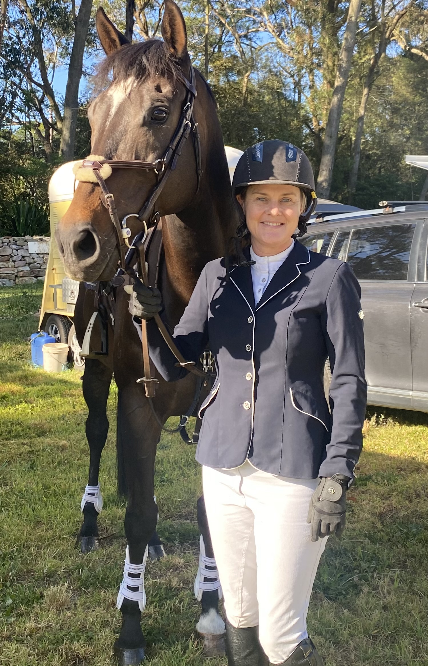 | Lisa Winn  ELECTED DIRECTOR  Lisa Winn combines corporate strategy, governance, marketing and innovation experience with a strong grassroots equestrian perspective. She joined the Equestrian NSW Board in 2021 and has chaired the ENSW Marketing & Communications Committee. Lisa also contributed to the 2023 Equestrian Australia Structural Reform Working Group, supporting work to simplify governance and clarify roles across the national system. Professionally, Lisa has more than 25 years of senior leadership experience, including senior director roles with Coca-Cola South Pacific across strategy, innovation, mergers and acquisitions, and marketing, as well as earlier experience with Unilever. She is also a founder in the NSW biotechnology sector. Lisa holds a Bachelor of Commerce (Honours - First Class) in Marketing from the University of Otago. An active amateur rider and equestrian parent, she brings a practical focus on participation, member experience, horse welfare, strategy, risk and clear communication.  Areas of expertise: Strategy & innovation | Governance & risk | Marketing | Stakeholder engagement

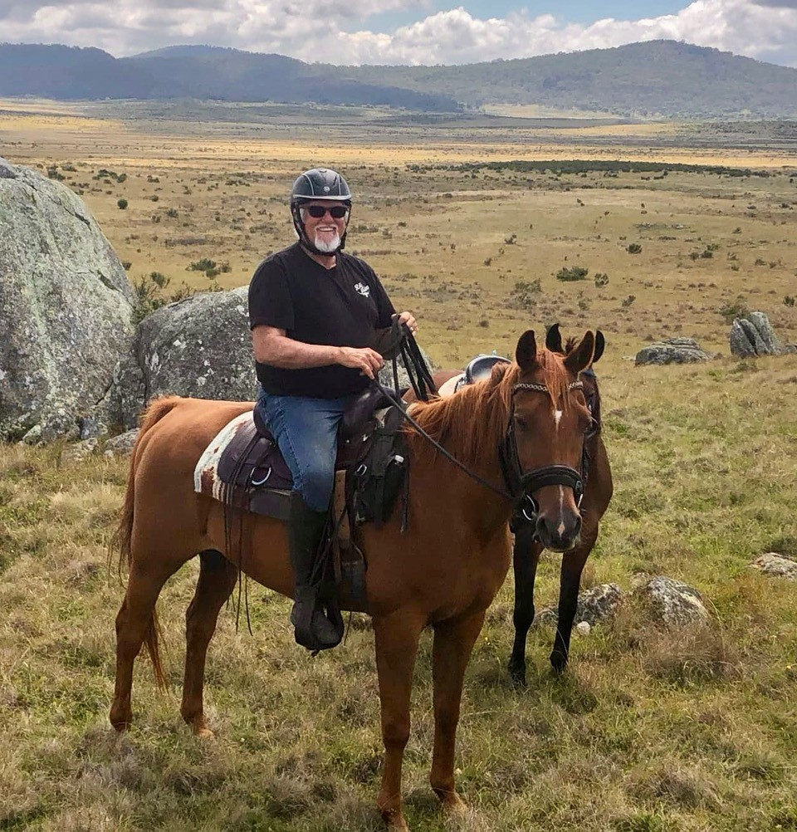 | Tony Harris  ELECTED DIRECTOR  Tony Harris brings nearly 20 years of board and governance experience across listed, private and not-for-profit organisations, supported by more than 40 years of professional experience in finance, property and construction. His leadership experience includes serving as a Non-Executive Director and CEO of an ASX-listed financial services company, with responsibilities across audit, risk and remuneration, as well as governance roles in philanthropy and social-impact organisations. Within equestrian sport, Tony has served as President and a committee member of Eventing NSW. He is an FEI Level 1 Steward and EA Level 2 accredited official and has competed in eventing, polo and polocrosse. Tony is trained in not-for-profit governance through the Australian Institute of Company Directors. He brings strong financial acumen, strategic thinking, risk management and stakeholder alignment, with a focus on stable governance and sustainable growth.  Areas of expertise: Finance | Governance & risk | Eventing | Strategy & organisational growth

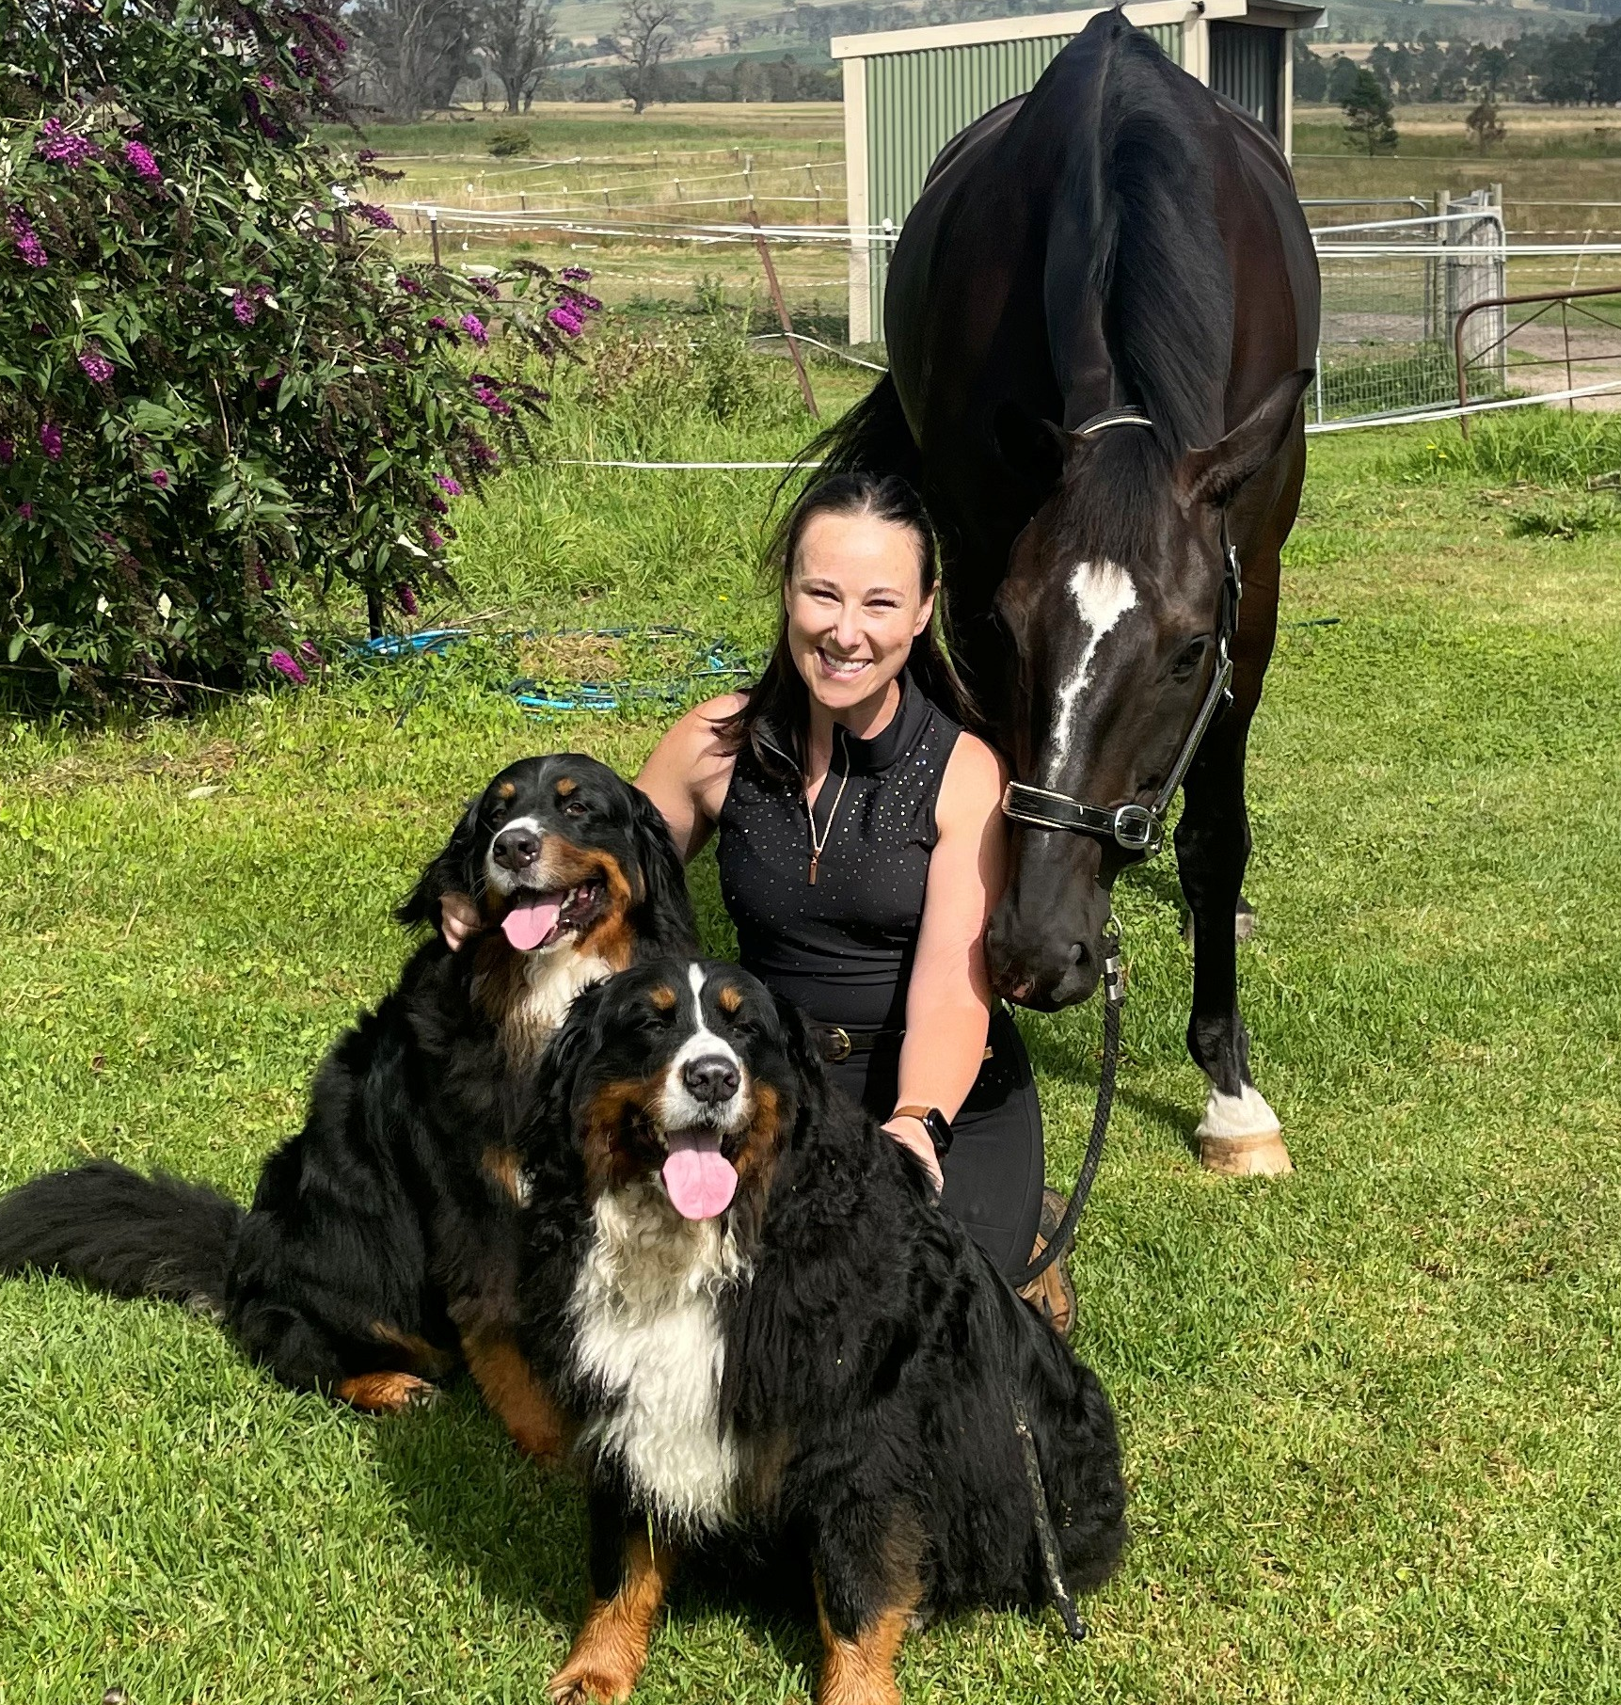 | Ellie Robinson  ELECTED DIRECTOR  Ellie Robinson is the Director of Collaboration and Strategic Change at Konrad & Co, where she leads strategy, transformation and collaboration programs for organisations tackling complex, system-wide challenges across government, sport and industry.  An experienced strategic leader, Ellie also brings executive experience in sport and membership organisations. As Chief Collaboration Officer at Cricket for Climate, Ellie led cross-sector programs across a network of more than 4,000 community clubs, state associations, stadiums and governing bodies. She has also worked with the Australian Institute of Sport and the Australian Sports Commission on the co-design of Australia's high-performance sport strategy to 2032, and has worked with the World Wildlife Fund on their national campaign to protect native forests.  Prior to her work in sport, Ellie was a senior leader in a large consulting firm, and led programs for the Department of Defence, Airservices Australia, the Murray–Darling Basin Authority and more, spanning corporate plans, operating models and organisational transformation.  Ellie has been involved with horses for more than 20 years, from Pony Club and Interschool competition to state-level dressage, vaulting and showjumping. She has recently returned to the sport after taking a break for her career, and now competes in dressage with her horse Samurai. She joined the Equestrian NSW Board in 2025 to help the sport bring more voices into how its future is designed.  Areas of expertise: Governance design | Collaboration | Transformation | Stakeholder engagement & communication

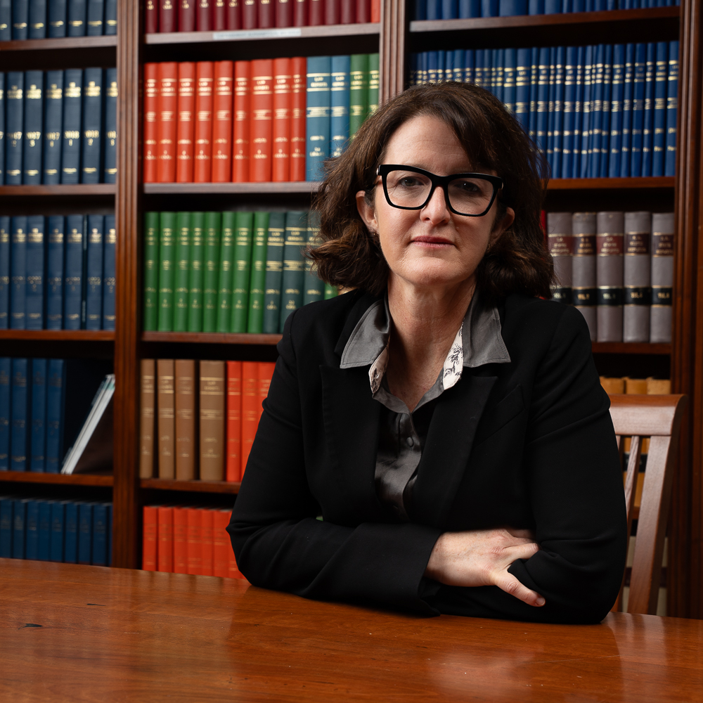 | Ann Bonnor  APPOINTED DIRECTOR  Ann Bonnor is a barrister with extensive experience across criminal trials and appeals, administrative and regulatory law, inquiries, inquests and disciplinary matters. She practises in courts at all levels and has a background in interpretation of statutes and government law. She holds a Bachelor of Laws (First Class Honours) and a Bachelor of Arts (International Studies) from the University of Technology Sydney, was admitted as a legal practitioner in 2001 and to the Bar in 2014. Ann's equestrian governance experience includes service on Equestrian Australia's National Integrity Committee, contributing to review of Equestrian Australia policies and codes. As an Appointed Director of Equestrian NSW, Ann brings strong legal and regulatory, enforcement, disciplinary and integrity expertise to the Board, supporting sound decision-making and robust organisational processes  Areas of expertise: Legal | Integrity | Governance | Risk & regulatory matters

