REGISTRATION No | NAME OF HORSE
PLEASE LIST THE NAMES AND ADDRESSES OF ALL NEW OWNERS
NEW PRIMARY OWNER'S NAME MEMBER NO.
NEW PRIMARY OWNER'S ADDRESS
SUBURB POST CODE

Phone: _____________________________Email: _________________________________________________
OTHER NEW OWNER/S (MUST BE CURRENT EA MEMBER/S) See EA General Regulations
NAME MEMBER NO.
NAME MEMBER NO.

COLOUR: |  |  | SEX: |  | ¨ Gelding ¨ Mare ¨ Stallion
BREED: |  | FOAL DATE: |  |  |  | HEIGHT in Hands:
MARKINGS: HEAD |  |  |  | SIRE:
NEAR FORE: |  |  |  | DAM:
OFF FORE: |  |  |  | SIRE OF DAM:
NEAR HIND:
OFF HIND: |  |  |  | BRAND N/S:
OTHER MARKINGS: |  |  |  | BRAND O/S:
 |  |  |  | MICROCHIP No:

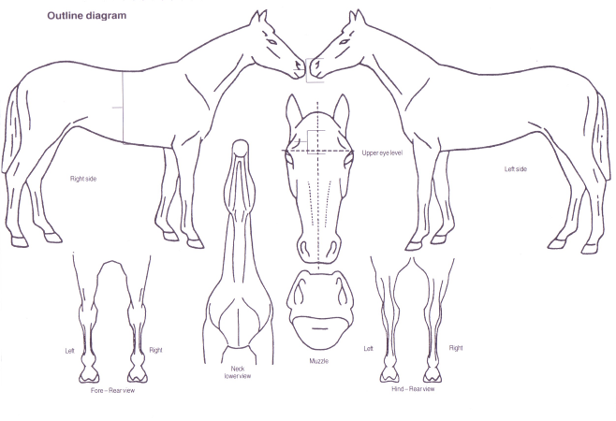
The Following Diagram must be completed accurately. Position of scars to be marked with an X. Whorls to be marked with an O

Commonwealth of Australia
STATUTORY DECLARATION
Statutory Declarations Act 1959
1 Insert the name, address and occupation of person making the declaration | I,¹  make the following declaration under the Statutory Declarations Act 1959:
2 Set out matter declared to in numbered paragraphs | ²  I understand that a person who intentionally makes a false statement in a statutory declaration is guilty of an offence under section 11 of the Statutory Declarations Act 1959, and I believe that the statements in this declaration are true in every particular.
3 Signature of person making the declaration | ³
4 Place  5 Day  6 Month and year | Declared at ⁴ on ⁵ of ⁶  Before me,
7 Signature of person before whom the declaration is made (see over) | ⁷
8 Full name, qualification and address of person before whom the declaration is made (in printed letters) | ⁸
Note 1 A person who intentionally makes a false statement in a statutory declaration is guilty of an offence, the punishment for which is imprisonment for a term of 4 years — see section 11 of the Statutory Declarations Act 1959.
Note 2 Chapter 2 of the Criminal Code applies to all offences against the Statutory Declarations Act 1959 — see section 5A of the Statutory Declarations Act 1959.
A statutory declaration under the Statutory Declarations Act 1959 may be made before–
(1) a person who is currently licensed or registered under a law to practise in one of the following occupations:
Chiropractor Dentist Legal practitioner
Medical practitioner Nurse Optometrist
Patent attorney Pharmacist Physiotherapist
Psychologist Trade marks attorney Veterinary surgeon
(2) a person who is enrolled on the roll of the Supreme Court of a State or Territory, or the High Court of Australia, as a legal practitioner (however described); or
(3) a person who is in the following list:
Agent of the Australian Postal Corporation who is in charge of an office supplying postal services to the public
Australian Consular Officer or Australian Diplomatic Officer (within the meaning of the Consular Fees Act 1955)
Bailiff
Bank officer with 5 or more continuous years of service
Building society officer with 5 or more years of continuous service
Chief executive officer of a Commonwealth court
Clerk of a court
Commissioner for Affidavits
Commissioner for Declarations
Credit union officer with 5 or more years of continuous service
Employee of the Australian Trade Commission who is:
(a) in a country or place outside Australia; and
(b) authorised under paragraph 3 (d) of the Consular Fees Act 1955; and
(c) exercising his or her function in that place
Employee of the Commonwealth who is:
(a) in a country or place outside Australia; and
(b) authorised under paragraph 3 (c) of the Consular Fees Act 1955; and
(c) exercising his or her function in that place
Fellow of the National Tax Accountants’ Association
Finance company officer with 5 or more years of continuous service
Holder of a statutory office not specified in another item in this list
Judge of a court
Justice of the Peace
Magistrate
Marriage celebrant registered under Subdivision C of Division 1 of Part IV of the Marriage Act 1961
Master of a court
Member of Chartered Secretaries Australia
Member of Engineers Australia, other than at the grade of student
Member of the Association of Taxation and Management Accountants
Member of the Australasian Institute of Mining and Metallurgy
Member of the Australian Defence Force who is:
(a) an officer; or
(b) a non-commissioned officer within the meaning of the Defence Force Discipline Act 1982 with 5 or more years of continuous service; or
(c) a warrant officer within the meaning of that Act
Member of the Institute of Chartered Accountants in Australia, the Australian Society of Certified Practising Accountants or the National Institute of Accountants
Member of:
(a) the Parliament of the Commonwealth; or
(b) the Parliament of a State; or
(c) a Territory legislature; or
(d) a local government authority of a State or Territory
Minister of religion registered under Subdivision A of Division 1 of Part IV of the Marriage Act 1961
Notary public
Permanent employee of the Australian Postal Corporation with 5 or more years of continuous service who is employed in an office supplying postal services to the public
Permanent employee of:
(a) the Commonwealth or a Commonwealth authority; or
(b) a State or Territory or a State or Territory authority; or
(c) a local government authority;
with 5 or more years of continuous service who is not specified in another item in this list
Person before whom a statutory declaration may be made under the law of the State or Territory in which the declaration is made
Police officer
Registrar, or Deputy Registrar, of a court
Senior Executive Service employee of:
(a) the Commonwealth or a Commonwealth authority; or
(b) a State or Territory or a State or Territory authority
Sheriff
Sheriff’s officer
Teacher employed on a full-time basis at a school or tertiary education institution

Equestrian NSW (ABN 17 157 619 696) and Equestrian Australia (ABN 19 077 455 755)
PO Box 7077, Wetherill Park BC NSW 2164
Ph: 02 9620 2660 Email: info@ensw.org.au Website: www.nsw.equestrian.org.au

This form becomes a Tax Invoice on payment. Please copy for your records

PAYMENT INFORMATION

** PLEASE ENSURE ALL DETAILS ARE COMPLETED **

Please accept my cheque/money order made out to Equestrian NSW for $...................
OR
Please charge my credit card:
- Visa
- Mastercard
- American Express

Number: __ __ __ __/ __ __ __ __/ __ __ __ __/ __ __ __ __ Expiry date: __ __/ __ __ CCV __ __ __ __

Name on Card: ____________________________________

Signature/Authorisation: ____________________________________

Being for:
- Horse Transfer Duplicate papers $142.00 $
Priority Processing* $100.00 $
(*on receipt of original document to be processed by COB next business day)

- Competition Licence – (please circle licence type required)
Dressage $40.00 ea $
Eventing $40.00 ea $
Jumping $41.00 ea $
Show Horse $22.00 ea $
- Express Postage: (for horse registration docs) $17.00 $

TOTAL PAID: $ ____________

Please note original documents are required for transfers – horse registration certificates or statutory declarations. For urgent transfers Priority Processing fee may be paid for next business day completion however must be original documents (no scanned copies)
If for any reason the processing of your payment is unsuccessful then your transaction will not be able to be completed.
The Equestrian NSW membership year runs from the 1 July to 30 June. Licences paid during the year will be due on 1 July.

